Effort and locomotor learning (split-belt adaptation)
Experimental Brief
rachel Marbaker (10 February 2023; updated 28 January 2025)

Question: How do differences in the physical effort of a task affect motor learning and savings in split-belt locomotion?

Predictions: In a high effort condition, the benefit of reducing metabolic cost increases, if this increased benefit partly drives motor learning, adaptation will be faster in the high effort condition. If, on the other hand, effort impairs learning, the higher effort cost will slow adaptation. Finally, effort may have no effect on the adaptation of step length asymmetry, though effort may change the adaptation process in other ways.

Motor Learning Overview: When normal movement is disrupted by an external perturbation, the brain quickly adjusts the movement to compensate for external conditions. In general these adjustments are attributed to error reduction via feedback control in the brain; however, research in reaching (Huang et al. 2012) and split-belt walking (Sánchez et al. 2019, 2021) shows that metabolic cost is reduced in parallel with error reduction during the learning process. We also observe that humans are willing to adjust their walking (in this case walking speed) away from preferred in order to reduce metabolic cost (Selinger et al. 2015).

We compare learning and savings by looking at error reduction curves. When the external perturbation is introduced (the split belt speeds in this case), people have an abrupt increase in error (asymmetry). Over time, people reduce their error, adjusting their movement to counter or accommodate the perturbation. Learning is characterized using the shape of the error reduction curve – faster error reduction (steeper descending slope) indicates faster learning. The error reduction generally reaches an asymptote after a long enough adaptation phase. Often the asymptote is short of full correction. Following the adaptation phase, we switch to a washout block where the external perturbation is removed. This also causes a sharp increase in error because participants initially rely on the learned compensation before correcting back to baseline. After washout, we reintroduce the perturbation to look how much of the adaptation is stored from the initial learning block; this is called savings. Because participants have learned the perturbation previously, they generally reduce error more quickly.

We are comparing learning as differentiated by effort. Effort is a bit of a slippery term, but the gold standard measure is metabolic cost (indicating more calories burned to complete the task). In our experiment, we are using added weight to increase metabolic cost and percieved effort, though we do not measure either.

Methods: In our experiment, participants walked on a split belt treadmill (one belt for each foot) for one of two effort conditions and a control group. A subset of participants completed both the high and low effort conditions. Effort conditions are differentiated by added weight worn in a weight vest. The control group wears the vest only, the low effort condition is 5% of body weight, and the high effort condition is 15% of body weight.
Participants completed baseline, learning, washout, and savings blocks. During the learning and savings blocks, participants walked with the belts at two different speeds, one belt ran at 15.m/s and the other belt ran at 0.5 m/s.
Throughout the walking task, we collect 3-dimensional force plate data (1000 Hz) using the two force plates embedded in the treadmill and motion capture data (100 Hz) on the lower body (Vicon Plug-In Gait model).
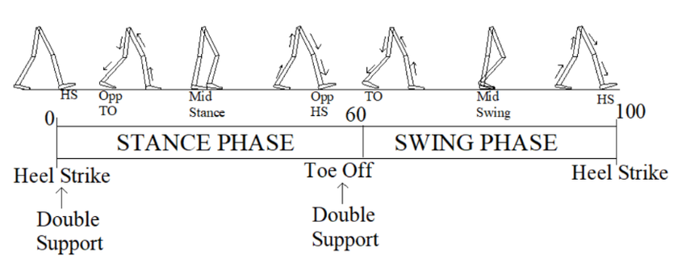
I used MATLAB scripts to filter and down sample the force plate data, then determined heel strike and toe off gait events.
(Figure above from Dewanjee, Adharaa & Hossain, Quazi Delwar & Muhury, Anik. (2019). Quantitative Deviation of Spatial Parameters of Gait in Parkinson’s Disease. 10.1109/WiSPN- ET45539.2019.9032870.)
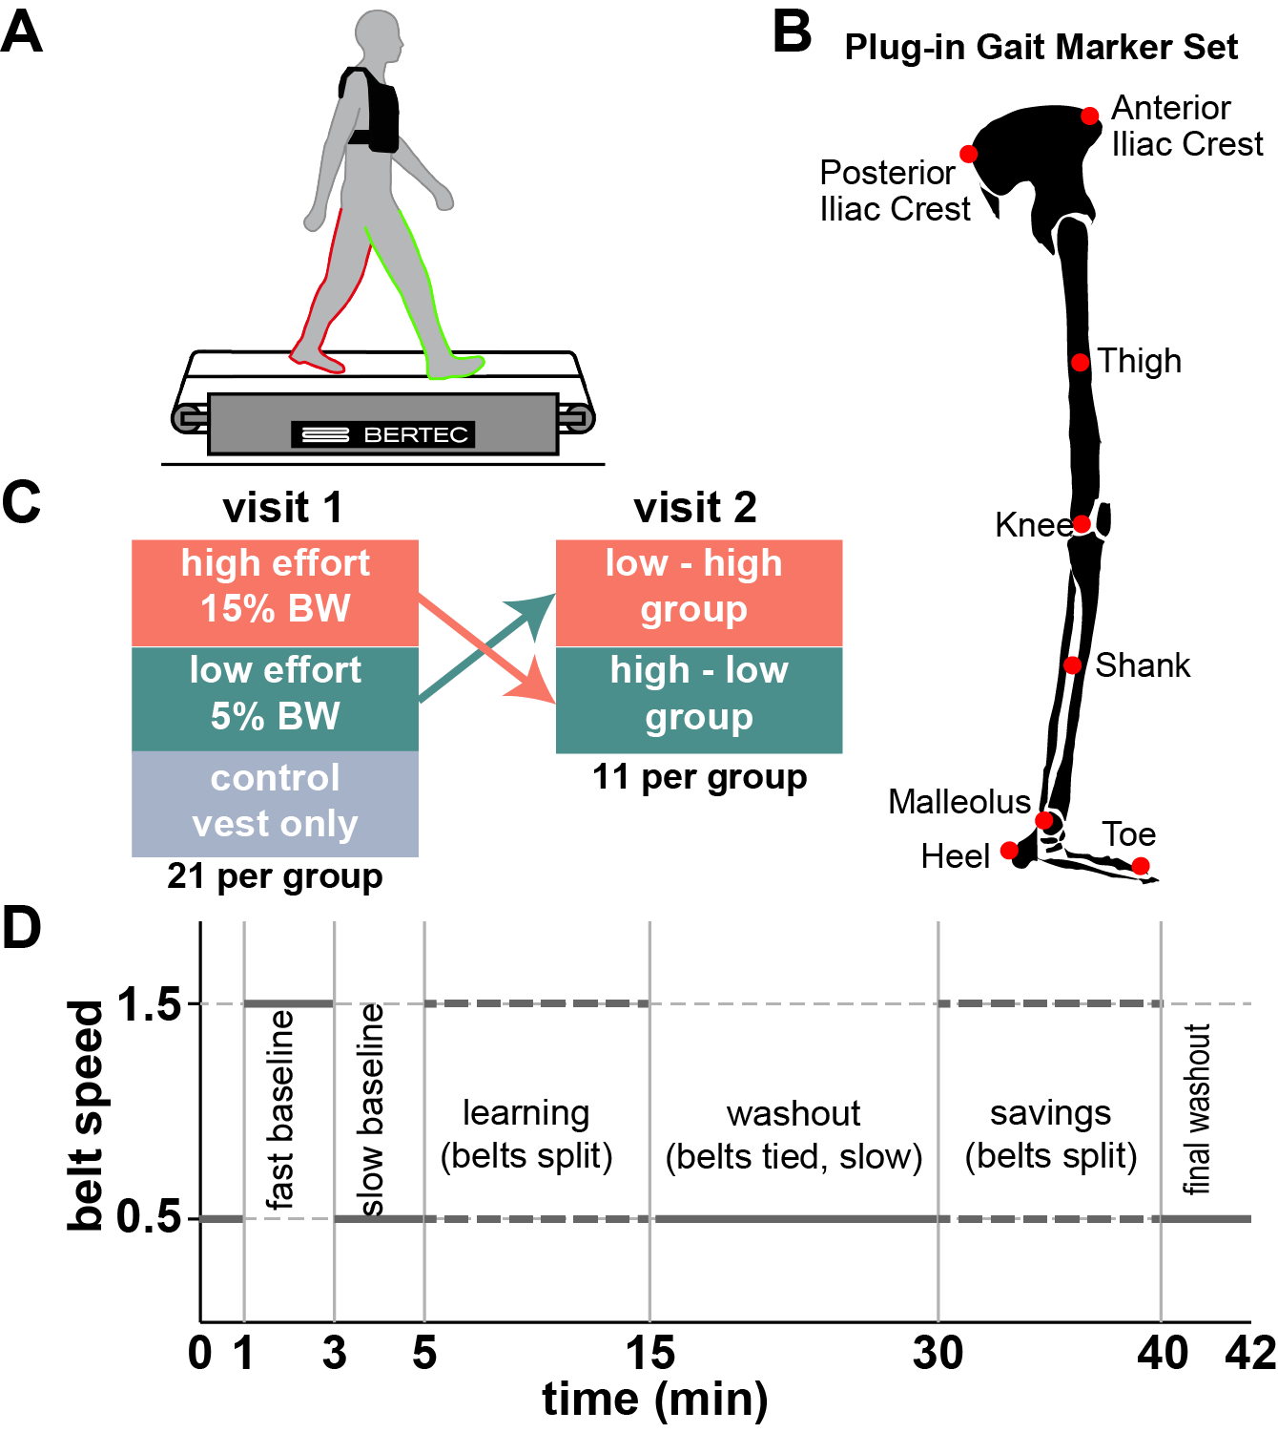
I used the gait events to index and sort the walking data into steps (defining a step from heel strike to heel strike on a single leg). This allowed me to calculate step length, width, and time and to identify peak forces and force integral measures for each step in each block.
My primary outcome measure is step length asymmetry and that is what I used to compare learning curves between effort conditions and between learning and savings.
$$SLA = \frac{{SL}_{fast} - {SL}_{slow}}{{SL}_{fast}+ {SL}_{slow}}$$
This means that I have lots of data in lots of formats, so the next step is to figure which data. Is most useful to you.

Sample | Type | Metric / definition
1000 Hz | For each foot: Force (X,Y,Z); At this stage, vertical ground reaction forces (Z) are negative when the foot is on the belt. Y-direction ground reaction forces are braking (negative force against the direction of forward motion) and propulsion (positive force in the direction of forward motion. Horizontal forces (X) are small and I need to check the directionality  Moments (X,Y,Z);  Center of Pressure (X,Y) | Outputs from the force plates with an origin at the rear left corner of the treadmill  X describes the direction across the two belts, perpendicular to the direction of movement  Y describes the direction forward to back on the two belts  Z describes the vertical direction above the belt
100 Hz | MoCap XYZ trajectories of Plug-In Gait
100 Hz in steps
Steps / Phase | Step time, step length, step width,
Processed step (requiring both R + L | Double stance time
Processed step – secondary | asymmetry
Block secondary | Learning rate, learning asymptote, forgetting factor | These describe the shape of the learning curve – the ones I am using now are the parameters of an exponential fit (coefficient, exponential rate, and constant) and the parameters of a recursive state space learning model (a remembering factor and a learning rate)

